My Family Health Portrait
Draft Content for Create/Edit History Screens and Submodals

Table of Contents
1. HOME PAGE 1
2. MY FAMILY HEALTH HISTORY 2
3. EDIT ME 3
4. EDIT RELATIVE 6
5. ADD A FAMILY MEMBER 9

HOME PAGE
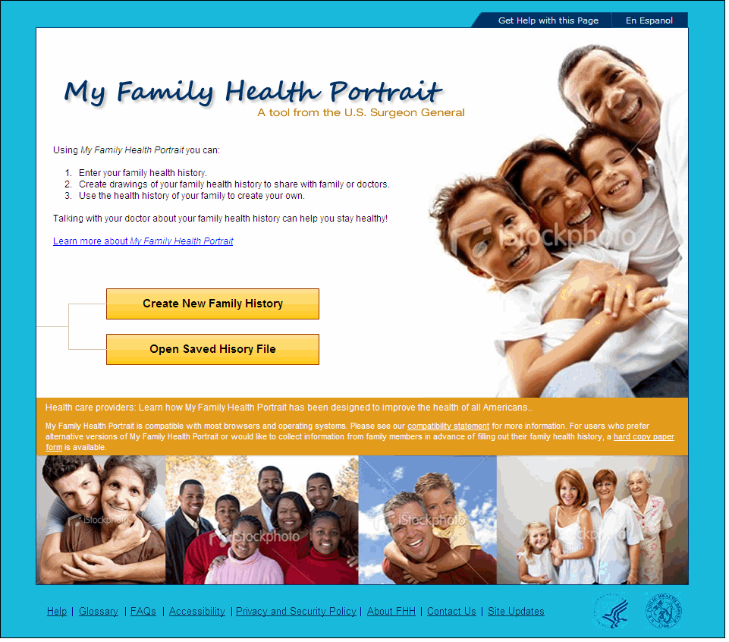
My Family Health Portrait
Using My Family Health Portrait, you can:
- Enter your family health history.
- Create drawings of your family health history to share with family or health care worker.
- Use the health history of your family to create your own.
Talking with your health care worker about your family health history can help you stay healthy!
Learn more about My Family Health Portrait
NOTE: The following “Health Care Provider” and “Accessibility” statements are displayed in the orange bar.
Health care providers: Learn how My Family Health Portrait can improve the health of all Americans.
My Family Health Portrait is compatible with most browsers and operating systems. Please see our compatibility statement for more information. Click here if you would like a printable version of My Family Health Portrait.

MY FAMILY HEALTH HISTORY
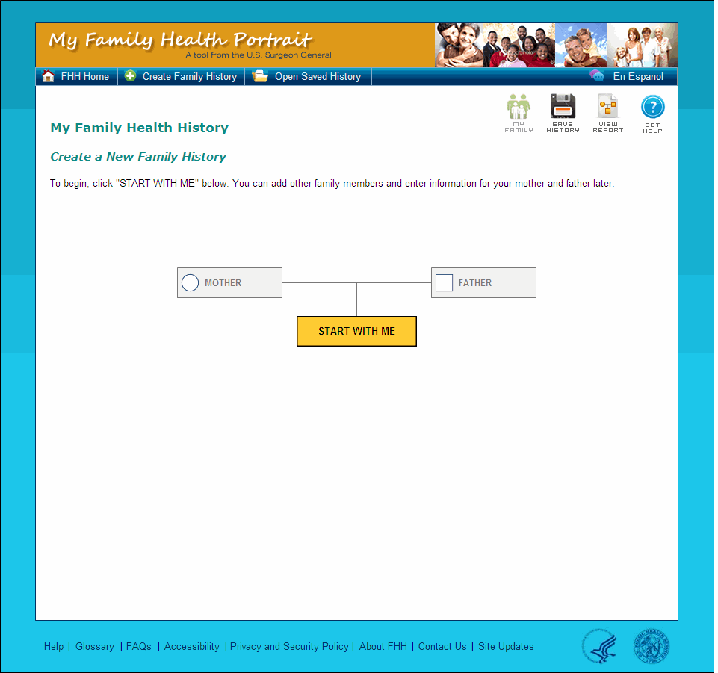
NOTE: When the user selects to Create a New Family Health History from scratch the My Family History page displays the following content:
My Family History
Create a New Family Health History
To begin, click "START WITH ME" below. You can add other family members and enter information for your mother and father later.
NOTE: Once the user has entered their information, but has not yet saved their file locally, the My Health History page displays the following content:
My Family History
Create a New Family Health History
On this screen, you can:
- Click on your mother or father and fill in their information
Or
- Add a family member by clicking "Add Family Member".
If you have finished filling out your family health history, click "Save History" image.

NOTE: Once the user has saved their history file locally and returned to the My Health History page or has successfully opened a saved history file, the My Health History page displays the following content:
My Family Health History
Update My Family History
On this screen, you can:
- Change a family member’s information by clicking on them.
Or
- Add a family member by clicking "Add Family Member".
If you have finished filling out your family health history, click "Save History" image.

EDIT ME
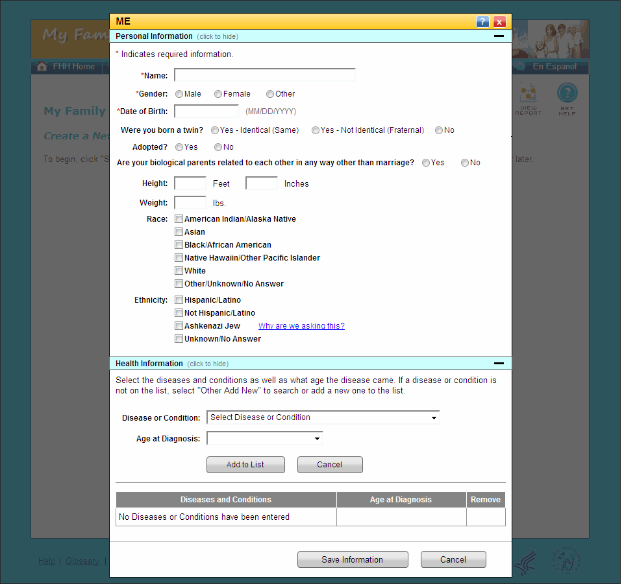

Personal Information
* Indicates required information

*Name:
*Gender:
- Male
- Female
- Other
Adopted?
- Yes
- No
*Date of Birth:
Were you born a twin?
- Yes – Identical (Same)
- Yes – Fraternal (Different)
- No
* Height:
- Feet
- Inches
Weight:
- Lbs.
Race:
- American Indian/Alaska Native
- Asian
- Asian Indian
- Chinese
- Filipino
- Japanese
- Korean
- Vietnamese
- Other Asian (Hmong, Laotian, Thai, Pakistani, Cambodian)
- Black/African American
- Native Hawaiian/Other Pacific Islander
- Native Hawaiian
- Guamanian
- Chamorro
- Samoan
- Other Pacific Islander (Fijian, Tongan, and so on)
- White
- Other/Unknown/No Answer
Ethnicity:
- Hispanic/Latino
- Not Hispanic/Latino
- Ashkenazi Jew Why are we asking this?
- Unknown/No Answer

Health Information
Select the diseases and conditions as well as what age the disease came. If a disease or condition is not on the list, select ‘Other – Add New’ to search or add a new one to the list.

Disease or Condition:
- Blood Clots
- Cancer
- Diabetes
- Gastrointestinal
- Heart Disease
- High Cholesterol/Hyperlipidemia
- Hypertension
- Kidney Disease
- Lung Disease
- Neurological Disorders
- Osteoporosis
- Psychological Disorders
- Septicemia
- Stroke/Brain Attack
- Sudden Infant Death Syndrome
- Other/Add New
- None
Age at Diagnosis:
- Pre-Birth
- Infant (29 days – 2 years)
- Childhood (2+ - 9 years)
- Adolescent (10 – 19)
- 20-29 years
- 30-39 years
- 40-49 years
- 50-59 years
- 60 and older
- Unknown

EDIT RELATIVE
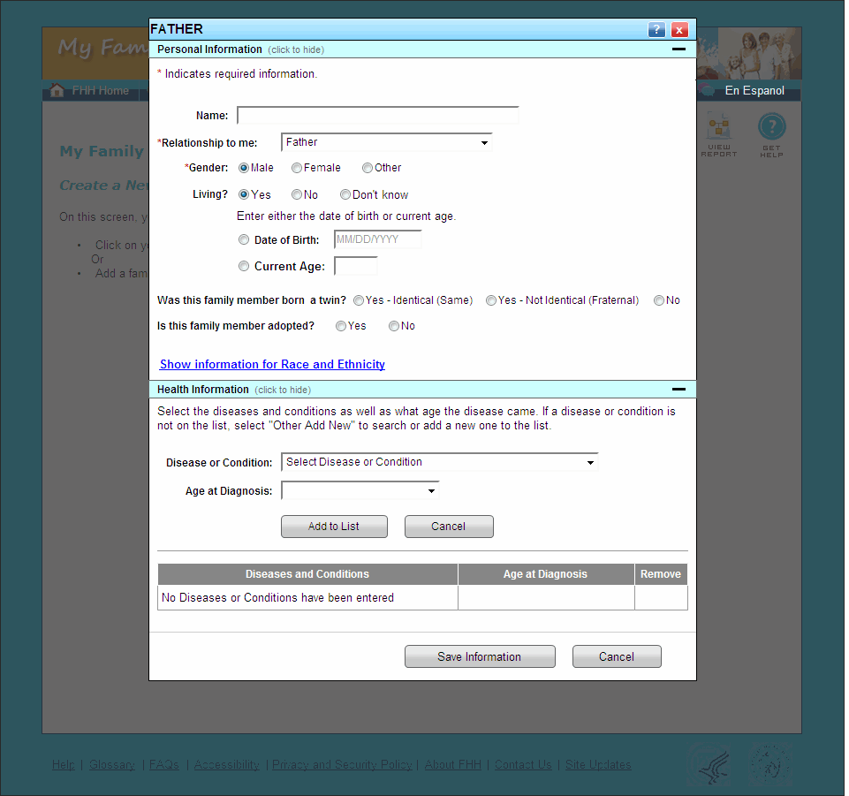
Personal Information
* Indicates required information

Name:
*Relationship to me:
- Mother (Biological)
- Father (Biological)
- Daughter
- Son
- Sister
- Brother
- Half-Sister
- Half-Brother
- Grandmother
- Grandfather
- Granddaughter
- Grandson
- Aunt
- Uncle
- Cousin
- Niece
- Nephew
*Gender:
- Male
- Female
- Other
Living?
- Yes
- Date of Birth
- Current Age
- No
- Age at Death
- Cause of Death
Was this family member born a twin?
- Yes – Identical (Same)
- Yes – Not Identical (Fraternal)
- No
Is this family member adopted?
- Yes
- No
Race:
- American Indian/Alaska Native
- Asian
- Asian Indian
- Chinese
- Filipino
- Japanese
- Korean
- Vietnamese
- Other Asian (Hmong, Laotian, Thai, Pakistani, Cambodian)
- Black/African American
- Native Hawaiian/Other Pacific Islander
- Native Hawaiian
- Guamanian
- Chamorro
- Samoan
- Other Pacific Islander (Fijian, Tongan, and so on)
- White
- Other/Unknown/No Answer
Ethnicity:
- Hispanic/Latino
- Not Hispanic/Latino
- Ashkenazi Jew Why are we asking this?
- Unknown/No Answer

Health Information
Select the diseases and conditions as well as what age the disease came. If a disease or condition is not on the list, select ‘Other – Add New’ to search or add a new one to the list.

Disease or Condition:
- Blood Clots
- Cancer
- Diabetes
- Gastrointestinal
- Heart Disease
- High Cholesterol/Hyperlipidemia
- Hypertension
- Kidney Disease
- Lung Disease
- Neurological Disorders
- Osteoporosis
- Psychological Disorders
- Septicemia
- Stroke/Brain Attack
- Sudden Infant Death Syndrome
- Other/Add New
Age at Diagnosis:
- Pre-Birth
- Infant (29 days – 2 years)
- Childhood (2+ - 9 years)
- Adolescent (10 – 19)
- 20-29 years
- 30-39 years
- 40-49 years
- 50-59 years
- 60 and older
- Unknown

ADD A FAMILY MEMBER
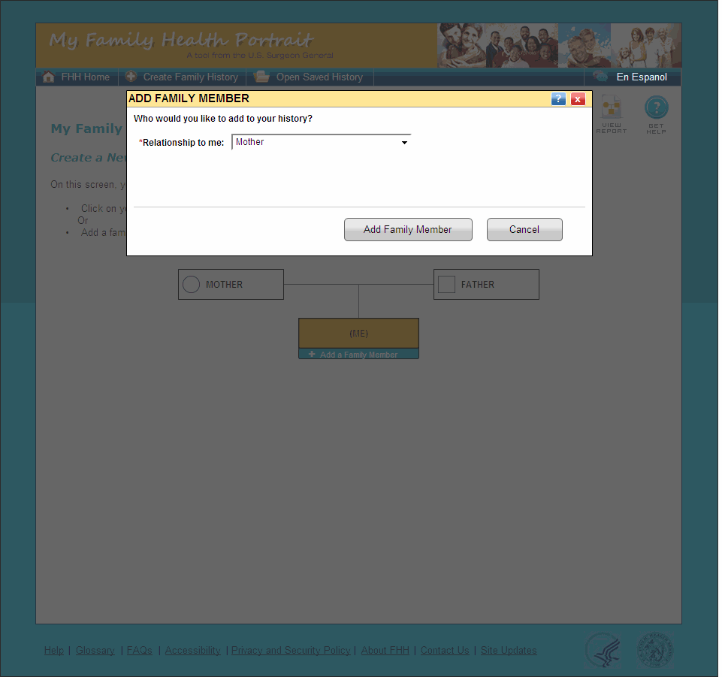
Whom would you like to add?
*Relationship to me:
- Mother
- Father
- Daughter
- Son
- Sister
- Brother
- Half-Sister
- Half-Brother
- Grandmother
- Grandfather
- Granddaughter
- Grandson
- Aunt
- Uncle
- Cousin
- Niece
- Nephew

